**WEEK 1**

1. Open power Bi App
2. Click on Blank Report
3. Click on Get data to extract data from CSV File

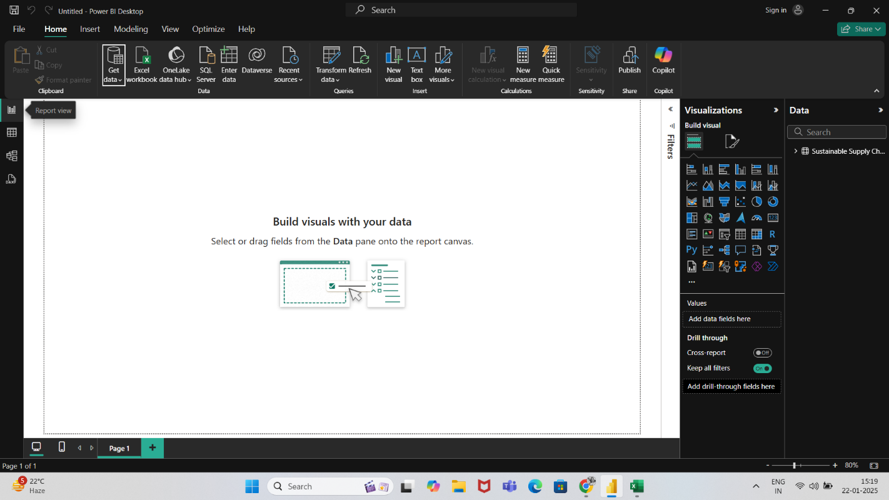

1. Click on Text/CSV option and then click on load option

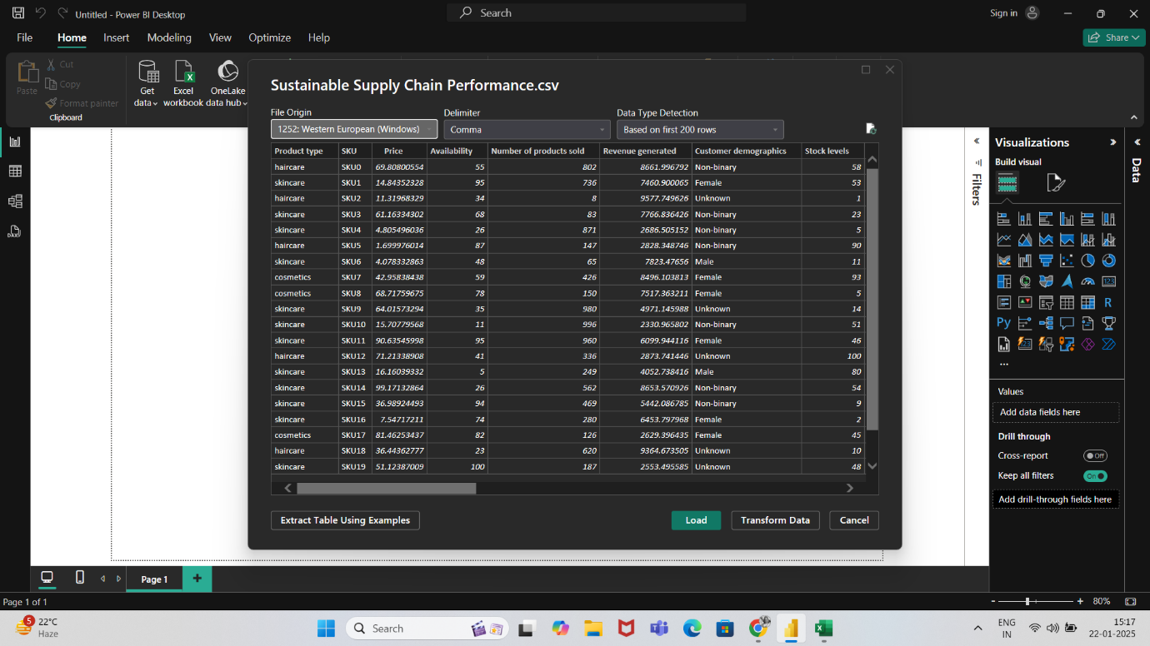

1. Go to Table view and the click on power query that will trigger a new window to open.

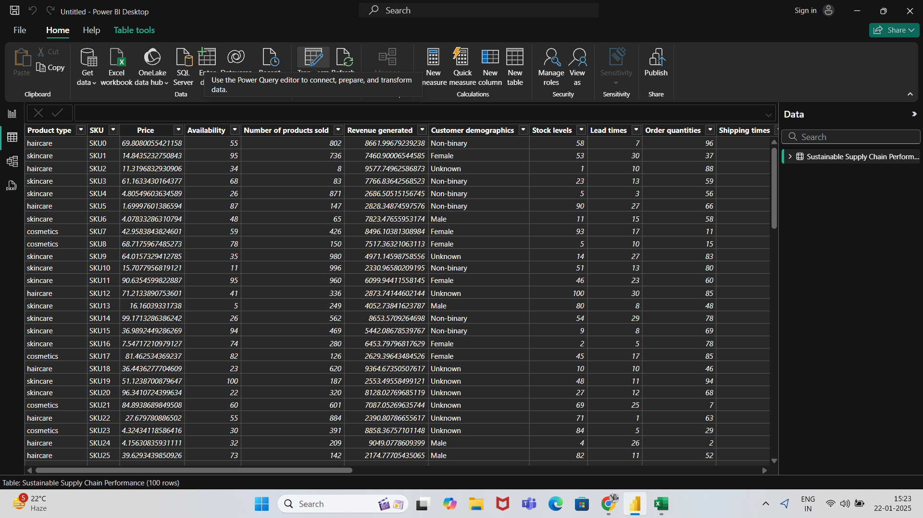

1. Now go to view tab and duplicate the original csv file and create the inventory table by removing unnecessary columns.

To remove unnecessary columns just right click on the column that you want to remove and select remove option from the dropdown.

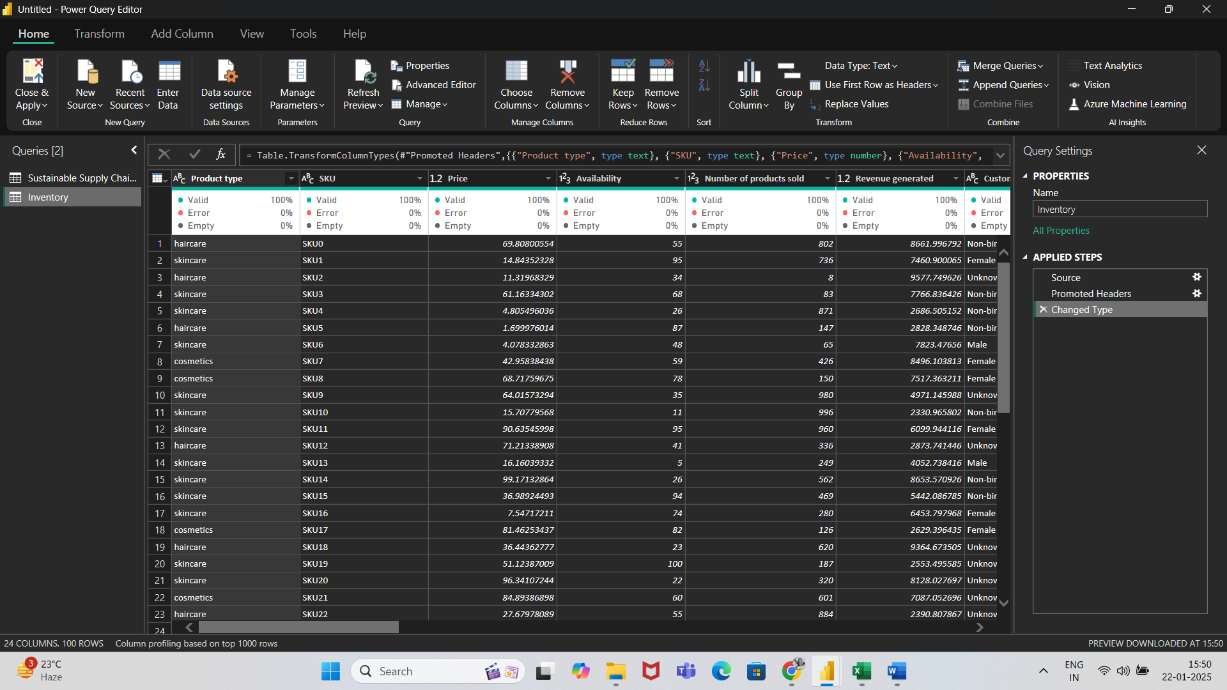

1. Similarly, create Manufacturing, Supplier and Supply Chain Tables

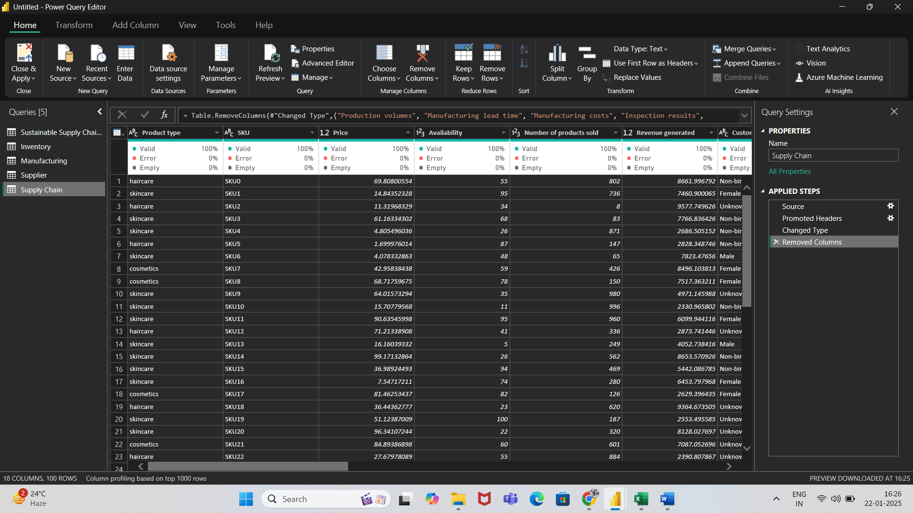

1. Then Select close and apply to save changes.

